11-08-2021

ABHINAV RANJAN

RA1911003010003

CSE A1 SECTION

SRMIST , KTR

**CN LAB EXP 4 – SOCKET PROGRAMMING USING UDP**

**SERVER SIDE SCREENSHOT :**

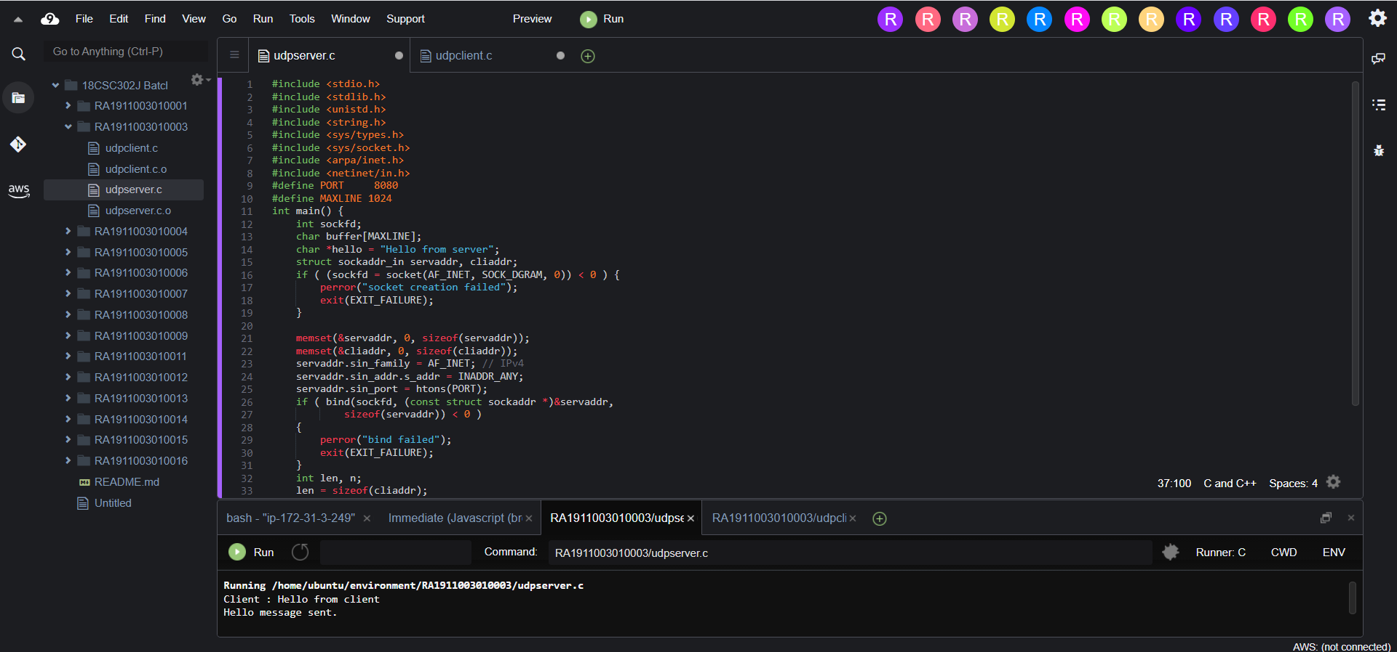

**SERVER CODE :**

#include <stdio.h>

#include <stdlib.h>

#include <unistd.h>

#include <string.h>

#include <sys/types.h>

#include <sys/socket.h>

#include <arpa/inet.h>

#include <netinet/in.h>

#define PORT 8080

#define MAXLINE 1024

int main() {

int sockfd;

char buffer[MAXLINE];

char *hello = "Hello from server";

struct sockaddr_in servaddr, cliaddr;

if ( (sockfd = socket(AF_INET, SOCK_DGRAM, 0)) < 0 ) {

perror("socket creation failed");

exit(EXIT_FAILURE);

}

memset(&servaddr, 0, sizeof(servaddr));

memset(&cliaddr, 0, sizeof(cliaddr));

servaddr.sin_family = AF_INET; // IPv4

servaddr.sin_addr.s_addr = INADDR_ANY;

servaddr.sin_port = htons(PORT);

if ( bind(sockfd, (const struct sockaddr *)&servaddr,

sizeof(servaddr)) < 0 )

{

perror("bind failed");

exit(EXIT_FAILURE);

}

int len, n;

len = sizeof(cliaddr);

n = recvfrom(sockfd, (char *)buffer, MAXLINE,MSG_WAITALL, ( struct sockaddr *) &cliaddr,&len);

buffer[n] = '\0';

printf("Client : %s\n", buffer);

sendto(sockfd, (const char *)hello, strlen(hello),MSG_CONFIRM, (const struct sockaddr *) &cliaddr,len);

printf("Hello message sent.\n");

return 0;

}

**CLIENT SIDE SCREENSHOT :**

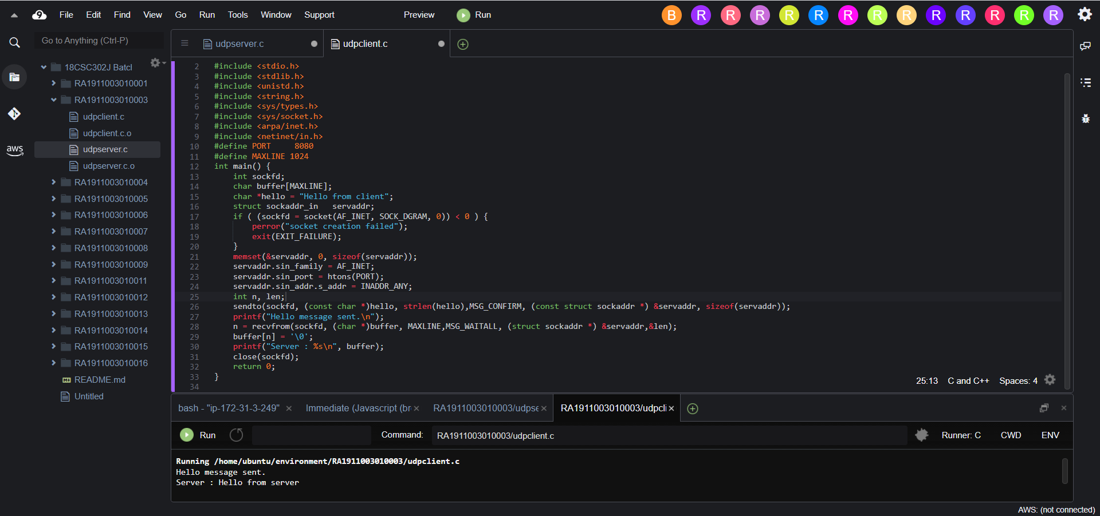

**CLIENT CODE :**

#include <stdio.h>

#include <stdlib.h>

#include <unistd.h>

#include <string.h>

#include <sys/types.h>

#include <sys/socket.h>

#include <arpa/inet.h>

#include <netinet/in.h>

#define PORT 8080

#define MAXLINE 1024

int main() {

int sockfd;

char buffer[MAXLINE];

char *hello = "Hello from client";

struct sockaddr_in servaddr;

if ( (sockfd = socket(AF_INET, SOCK_DGRAM, 0)) < 0 ) {

perror("socket creation failed");

exit(EXIT_FAILURE);

}

memset(&servaddr, 0, sizeof(servaddr));

servaddr.sin_family = AF_INET;

servaddr.sin_port = htons(PORT);

servaddr.sin_addr.s_addr = INADDR_ANY;

int n, len;

sendto(sockfd, (const char *)hello, strlen(hello),MSG_CONFIRM, (const struct sockaddr *) &servaddr, sizeof(servaddr));

printf("Hello message sent.\n");

n = recvfrom(sockfd, (char *)buffer, MAXLINE,MSG_WAITALL, (struct sockaddr *) &servaddr,&len);

buffer[n] = '\0';

printf("Server : %s\n", buffer);

close(sockfd);

return 0;

}